# M1C2 UI/UX Assignment

**Task One:** Referencing this image, create a low-fidelity wireframe.

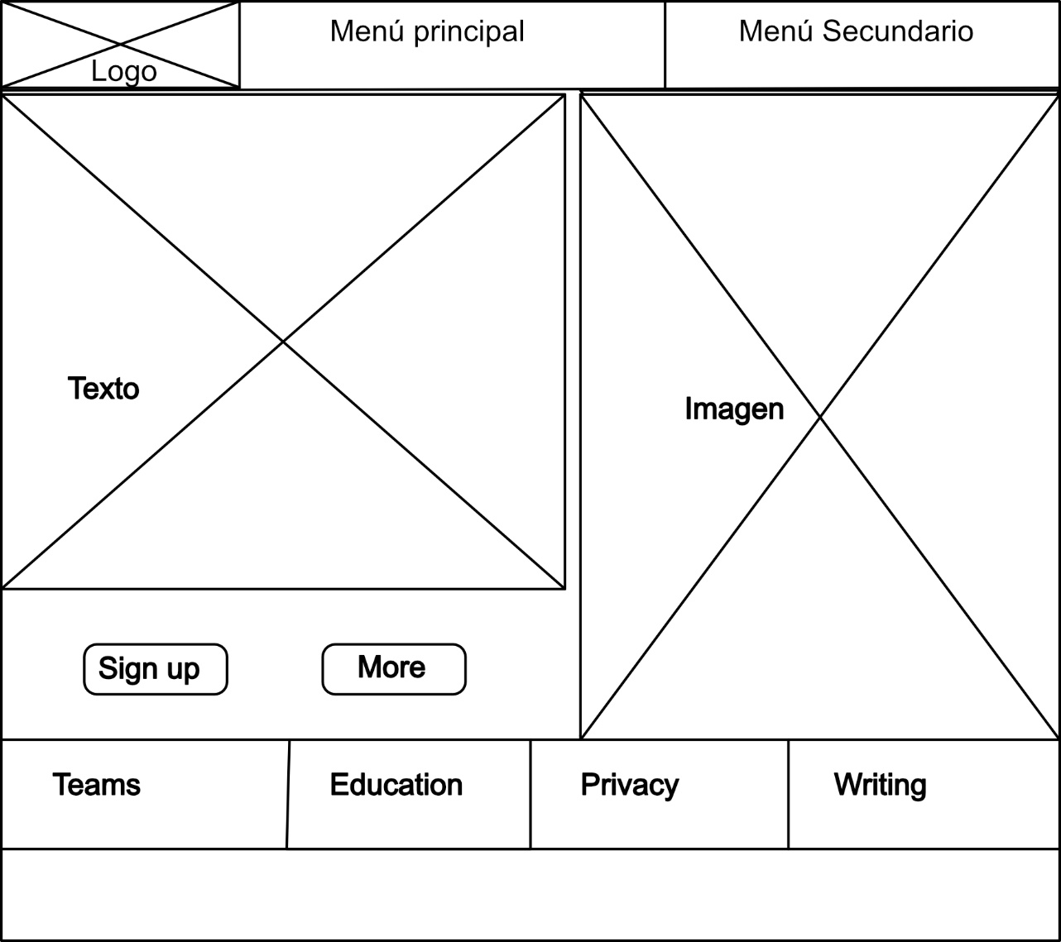

**Task Two:** Use one of the following websites and the inspect tool to identify 2-3 colors used repeatedly as part of the site’s color scheme. Remember that different shades of gray and black can be included as a color.

https://sebkay.com:

* #4b6cc1: Accent line below the name.
* #f9322c: Post category button (a.tag).
* #191a1d: Tags H, a and a.tag:hover.
* #4b6cc1: Tag a:hover.

**Task Three:** Create a user story by referencing one of these websites

Twitter:

John is an occasional Twitter user who wants to keep up with what's new in the publishing industry.

To do this he needs to be able to locate and follow accounts of writers, publishers, bookstores and reading forums, and he wants to be able to sort them into groups.

He also wants to be able to exchange opinions, links and images with all of them, both openly and privately.

He would like to be able to receive notifications as well as block and report aggressive users.

**Task Four:** Identify the prime objective of Facebook, Twitter, Google, and Youtube.

The business objective of these companies is to obtain profits through the presentation of advertisements, and for this purpose they pursue the retention of the user as long as possible.

The model they follow is different.

* **Facebook**: Facilitates communication among friends, as well as with groups and entities of interest to the user. Also, entertainment (reels).
* **Twitter**: Facilitates the user the possibility of being updated, in a fast and agile way, of the news of their interest, as well as to participate in the debates.
* Google: Provides relevant information on the searches performed by the user.
* **Youtube**: Offers audiovisual content basically of three types: entertainment, educational and videoblogs. Then there are current affairs contents and also institutional contents of companies or governments. It also promotes comments and interaction with the contents and creators.